ER Diagram in 3rd Normal Form

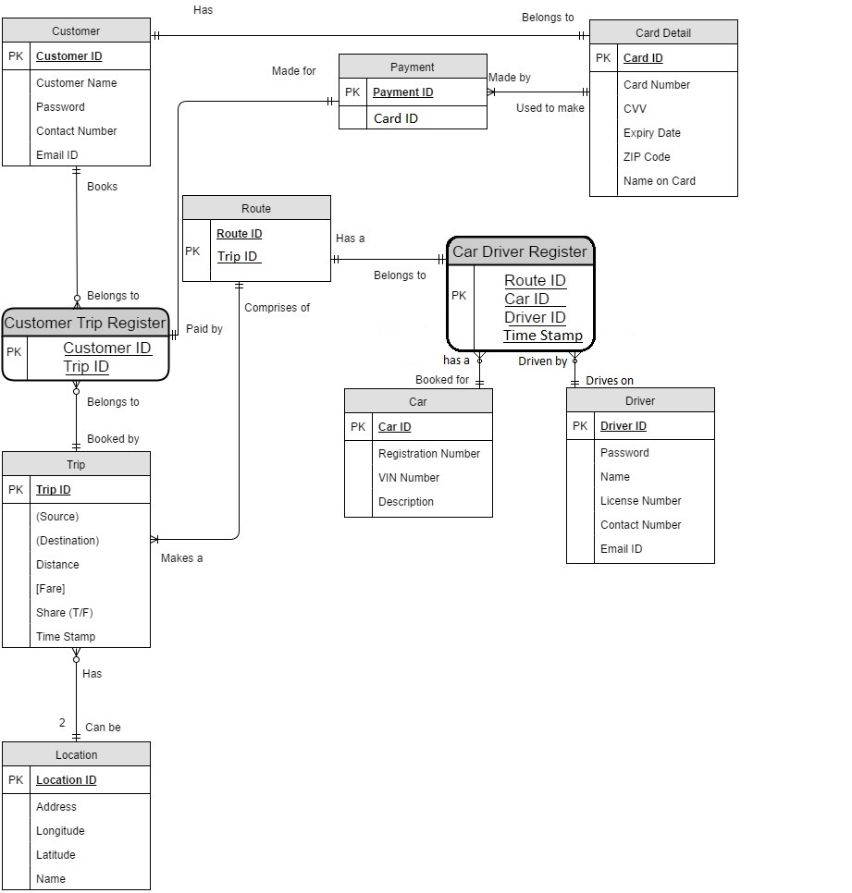

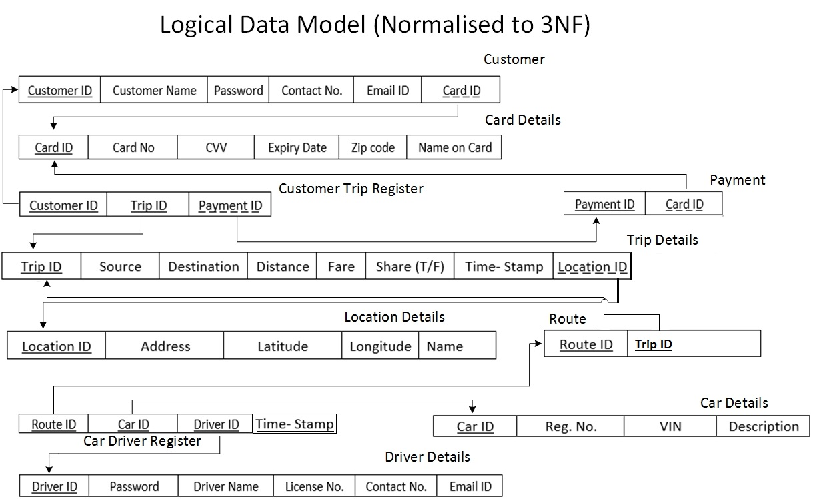

**Conversion of ER Diagram in to Collection Schema**

1. Entity “Card Detail” & “Customer” are combined into a single Collection called “Customer” by embedding “Card Detail” Collection into it. This is equivalent one-to-one relationship in RDBMS.

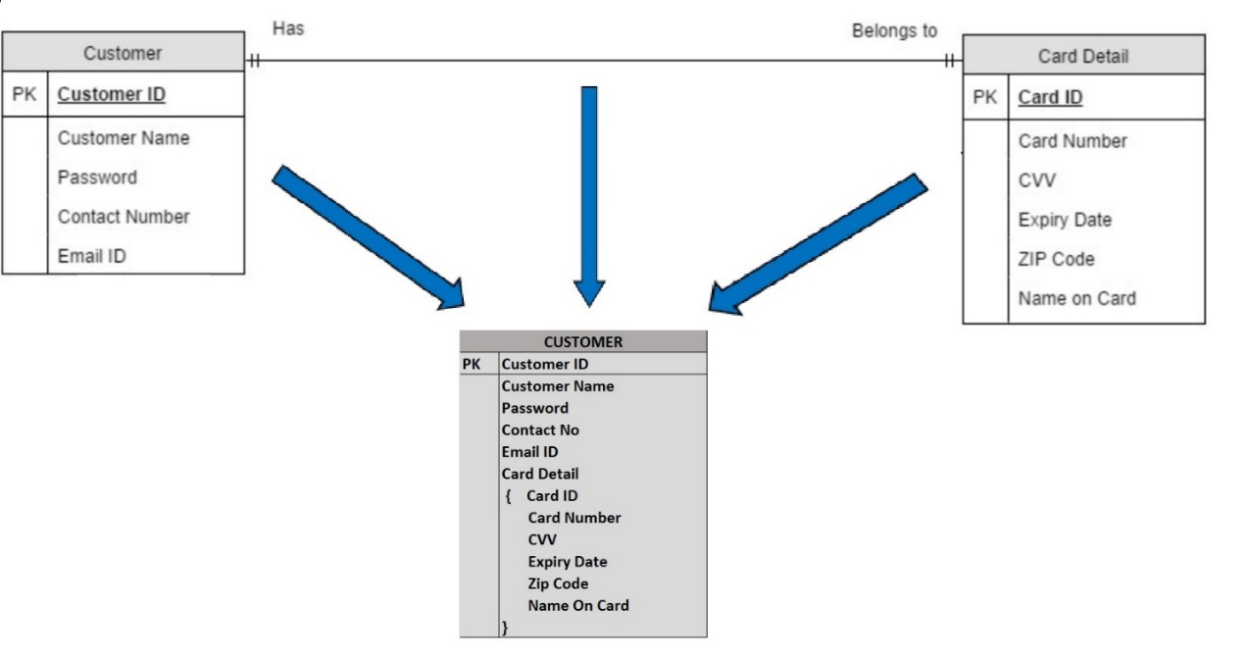

1. 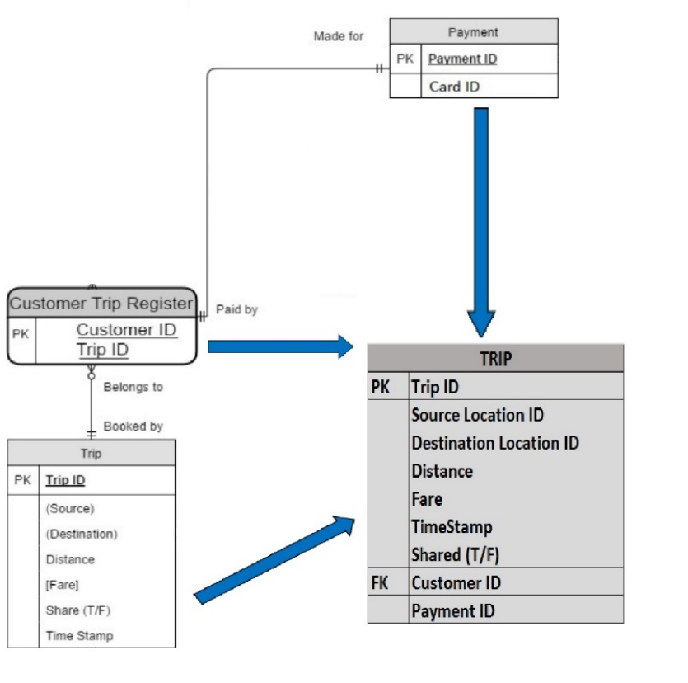Entities “ Trip”,”Customer Trip Register” & “Payment” are converted into a single Collection called “Trip”.
2. Since a route can have multiple trips, in order to show one-to-many relationship in collection schema, we combined the “Route” & “Car Driver Register” into single Collection where a Trip Id Key can hold multiple values (Trip ID1,Trip ID2 etc.).

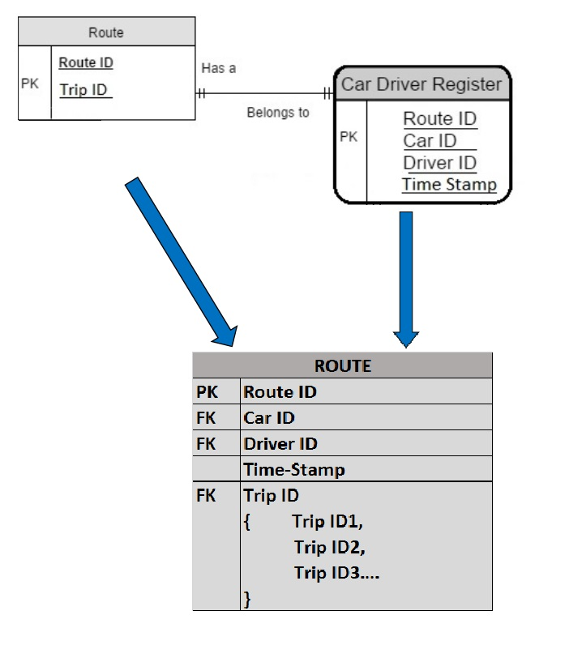

4. Entities “Driver,” “Car” & “Location” were directly taken as collections into MongoDB.

After converting each entity into equivalent collection, we were left with 6 Collections. Which in RDBMS corresponded to 7 Basic entities and two associative entities in RDBMS.

Below are the screen shots of 1 document from each of the collection:

**Note:**

* Collection is equivalent to a Table
* Object Id is equivalent to primary key in Mongo DB and is by default denoted by “_id”

1. **Collection: Customer**

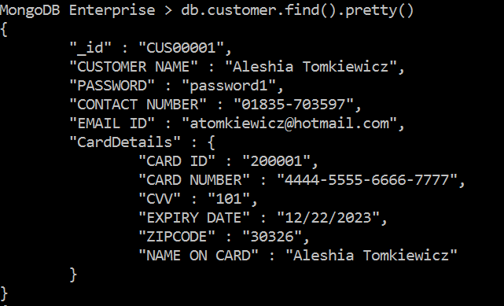

1. **Collection: Trip**

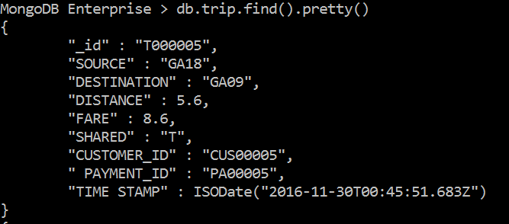

1. **Collection: Cars**

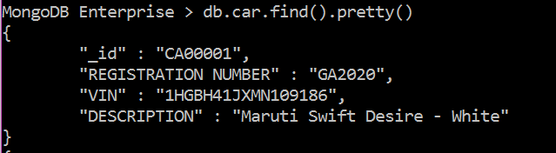

1. **Collection: Driver**



1. **Collection: Route**

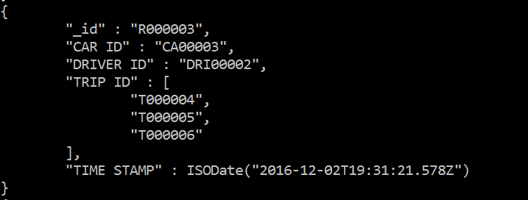

1. **Collection: Location**

